**Cyber Commerce**

**A Project Report**

***Submitted by***

**BHARGAV GOHEL**

**190210107021**

***In partial fulfillment for the award of the degree of***

**BACHELOR OF ENGINEERING**

***In***

**Computer Engineering**

**Government Engineering College, Bhavnagar**

**Gujarat Technological University, Ahmedabad**

**April – 2023**

**  
Government Engineering College, Bhavnagar**

**Near BPTI Campus, Vidhyanagar, Bhavnagar, Gujarat-364001  
CERTIFICATE**

This is to certify that the project report submitted along with the project entitled **Cyber Commerce** has been carried out by **Bhargav Gohel** under my guidance in partial fulfilment for the degree of Bachelor of Engineering in Computer Engineering, 8th Semester of Gujarat Technological University, Ahmedabad during the academic year 2022-23.  
  
  
  
 Prof. C. A. Vyas Prof. K. P. Kandoriya

Internal Guide Head of Department

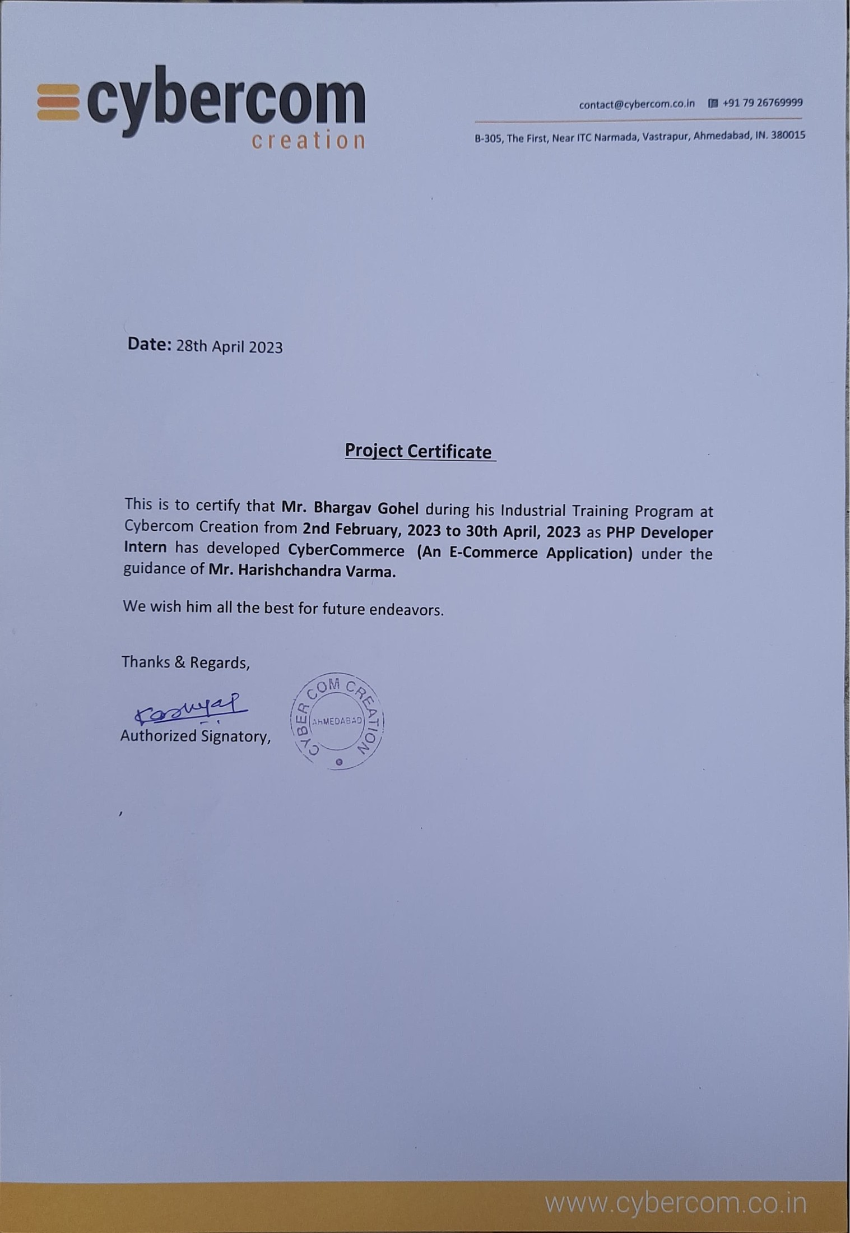

**  
Government Engineering College, Bhavnagar**

**Near BPTI Campus, Vidhyanagar, Bhavnagar, Gujarat-364001**

**DECLARATION**

We hereby declare that the Internship / Project report submitted along with the Internship / Project entitled **Cyber Commerce** submitted in partial fulfilment for the degree of Bachelor of Engineering in Computer Engineering to Gujarat Technological University, Ahmedabad, is a bonafide record of original project work carried out by me at **Cybercom Creation Pvt. Ltd.** under the supervision of **Mr. Harish Varma** and that no part of this report has been directly copied from any students’ reports or taken from any other source, without providing due reference.  
  
 Name of the Student Sign of the Student

Bhargav Gohel

## ACKNOWLEDGEMENT

It gives me great pleasure in expressing thanks and profound gratitude to “**Mr. Harishchandra Varma**” (Project Manager, Cybercom Creation Pvt. Ltd., Ahmedabad) for his continued support throughout the Internship. I would also like to thank my Faculty Guide, “**Prof. C. A. Vyas**”, Department of Computer Engineering, Government Engineering College, Bhavnagar for his valuable guidance and continual encouragement throughout the Internship.

I convey thanks to my project guide **“Prof. K. P. Kandoriya”**, Head of the department of the Computer Engineering Department, GEC - Bhavnagar for providing encouragement, constant support and guidance which was of a great help to complete this project work successfully. And thanks to Training and Placement Cell GEC- Bhavnagar and principal, “**Dr. G. P. Vadodaria”** for this opportunity and support.

I am thankful to all faculty members of the Computer Engineering Department, Government Engineering College, Bhavnagar for their special attention and suggestions towards the Internship.

I am also thankful to the employees of Cybercom Creation Pvt. Ltd. for support and encourage me toward the training.

The satisfaction that accompanies the successful completion of this project would be incomplete without mentioning the people who made it possible, without whose constant guidance and encouragement would have made efforts go in vain. I consider myself privileged to express gratitude and respect towards all those who has guided through the completion of projects.

## ABSTRACT

*This project aims to develop Cyber Commerce, an online store that provides a platform for users to purchase various items securely and conveniently. The store allows users to browse products, view prices, read descriptions and reviews, and purchase items using a secure online payment system. The store provides a comprehensive list of products displayed online, organized into different categories for easy browsing. Users can add their preferred products to their shopping cart and choose from a variety of payment options to complete their purchase. The system consists of two main modules: the Admin Module and the User Module. The Admin Module can only be accessed with an administrator password, and allows the administrator to save, edit, or delete product and category details. The module also enables the administrator to view all product and order details. The User Module allows customers to view product details, make purchases, and pay for orders online. Customers must log in to the system before placing an order, and can pay using credit card transactions. Overall, Cyber Commerce provides a seamless and user-friendly online shopping experience for customers.*

## LIST OF FIGURES

Fig 1.1 Company Logo 1

Fig 1.3.1 Organization Chart 2

Fig 2.3.1 Project Scheduling 5

Fig 3.7.1 Gantt Chart 14

Fig 5.1.1 1 Use Case Diagram 21

Fig 5.1.2.1 Activity Diagram 22

Fig 5.1.3.1 Sequence Diagram of Product Module 23

Fig 5.1.3.2 Sequence Diagram of Eav-Attribute Module 24

Fig 5.1.3.3 Sequence Diagram of Quote Module 25

Fig 5.2.1 Database Design 26

Fig 5.3.1 State Transition Diagram 27

Fig 5.3.2.1 Customer Login 28

Fig 5.3.2.2 Customer Registration 28

Fig 5.3.2.3 Update Customer Address 29

Fig 5.3.2.4 Update Profile 29

Fig 6.3.1 Home Screen 31

Fig 6.3.2 Services 31

Fig 6.3.3 Featured Products 32

Fig 6.3.4 Product View 32

Fig 6.3.5 Customer Dashboard 33

Fig 6.3.6 Cart 33

Fig 6.3.7 Checkout 34

Fig 6.3.8 Payment Method 34

Fig 6.3.9 Admin Panel 35

Fig 6.3.10 Manage Category 35

Fig 6.3.11 Manage Products 36

Fig 6.3.12 Manage Orders 36

Fig 6.3.13 Add Product 37

## LIST OF TABLE

Table 7.2.1 Test Cases for Product Module 39

Table 7.2.2 Test Cases for Order Module 39

Table 7.2.3 Test Cases for Customer Module 40

## LIST OF ABBREVIATIONS

|  |  |
| --- | --- |
| **HTML** | : Hypertext Markup Language |
| **CSS** | : Cascading Style Sheets |
| **SQL** | : Structured Query Language |
| **MySql** | : My Structured Query Language |
| **PHP** | : Hypertext Pre-processor |
| **IT** | : Information Technology |
| **B2B** | : Business to Business |
| **B2C** | : Business to Consumer |
| **API** | : Application Programming Interface |
| **CMS** | : Content Management System |
| **CRM** | : Customer Relationship Management |
| **CV** | : Curriculum Vitae |
| **MVC** | : Model-View-Controller |
| **MVVM** | : Model-View-View-Model |
| **ORM** | : Object-Relational Mapping |
| **IDE** | : Integrated Development Environment |
| **GUI** | : Graphical User Interface |

Table of Contents

Acknowledgement I

Abstract ii

List Of Figures iii

List Of Table iv

List Of Abbreviations v

Chapter 1 Overview Of The Company 1

1.1 History 1

1.2 Scope Of Work 2

1.3 Organization Chart 2

1.4 Capacity Of Plant 2

Chapter 2 Overview Of Different Department 4

2.1 Work Being Carried Out In Each Department 4

2.1.1 E-Commerce - Cms Solutions 4

2.1.2 Mobile Application 4

2.2 Technical Specification 4

2.3 Schematic Procedure For Manufacturing A Ecommerce Project 5

Chapter 3 Introduction To Internship 6

3.1 Internship Summary 6

3.2 Purpose 7

3.3 Objective 7

3.4 Scope 8

3.5 Technology And Literature Review 8

3.5.2 Literature Review 10

3.6 Project Planning 11

3.6.1 Project Development Approach And Justification 11

3.6.2 Project Effort And Time, Cost Estimation 12

3.6.3 Roles And Responsibilities 12

3.6.4 Group Dependencies 13

3.7 Project Scheduling (Gantt Chart) 14

Chapter 4 System Analysis 15

4.1 Study Of Current System 15

4.2 Problem And Weaknesses Of Current System 15

4.3 Requirements Of New System 16

4.4 System Feasibility 17

4.5 Proposed System 19

4.6 Features Of Proposed System 19

4.7 List of Main Modules 19

4.8 Selection Of Hardware / Software 20

Chapter 5 System Design 21

5.1 System Design & Methodology 21

5.1.1 Use Case Diagram 21

5.1.2 Activity Diagram 22

5.1.3 Sequence Diagrams 23

5.2 Database Design 26

5.3 Interface Design 27

5.3.1 State Transition Diagram 27

5.3.2 Samples Of Forms, Reports And Interface 28

Chapter 6 Implementation 30

6.1 Implementation Platform 30

6.2 Process And Technology 30

6.3 Results 31

Chapter 7 Testing 38

7.1 Testing Plan / Strategy 38

7.2 Test Results And Analysis 38

7.2.1 Test Cases For Product Module 39

7.2.2 Test Cases For Order Module 39

7.2.3 Test Cases For Customer Module 40

Chapter 8 Conclusion And Discussion 41

8.1 Overall Analysis Of Internship 41

8.2 Dates Of Continuous Evaluation 41

8.3 Summary Of Internship 41

8.4 Limitation And Future Enhancement 42

8.4.1 Limitations 42

8.4.2 Future Enhancement 42

References 44

# CHAPTER 1 OVERVIEW OF THE COMPANY

## 1.1 HISTORY

Cybercom Creation was commenced by an enterprising team of professionals with a strong focus on providing services and solutions. Today Cybercom has grown its team of dedicated specialists to more than 150+ employees.

With over 20 years of experience and 190+ employees on board, Cybercom serves startups to well-established companies globally. Over the years, we have succeeded in assembling a dedicated team of experts having extensive experience in various industry verticals. We stick to the latest industry trends and quality standards to deliver powerful and secure software that fits business requirements perfectly and brings a positive user experience. We have been delivering effective digital solutions with the use of innovative technologies, result-driven project management, and seamless communication. With our state-of-the-art facilities, high-tech IT infrastructure, dynamic team & superb work environment, Cybercom becomes an ideal IT partner for offshore software services as well as web & mobile app development projects.

We are an elite squad of digital commerce and have established a reputation for always bringing excellence to the table for every project. Bring to us your most intricate business challenges, and we will turn them into real digital commerce breakthroughs. Our team of certified developers can effortlessly execute the most complex integrations and help you develop rapidly growing, high-earning, and customer-centric eCommerce solutions. Developing new capabilities and responding to the technology needs of tomorrow, our team lives, breathes, and dreams about technology. The diversity, commitment, and expertise of our team working cohesively with our clients, and partners, inspire our vision: to be a global leader in IT solutions and services**.**



Fig1.1 Company Logo

## 1.2 SCOPE OF WORK

* Consulting: Providing expert advice and recommendations to clients regarding their business strategies, operations, or specific projects.
* Design: Creating visual and functional concepts and plans for various products or services.
* Development: Building and coding software, websites, or applications, using various programming languages and tools.
* Data: Collecting, analyzing, and interpreting large sets of data to draw meaningful insights and inform decision-making.
* Management: Planning, organizing, coordinating, and controlling resources and activities to achieve specific goals and objectives of a project or organization.

## 1.3 ORGANIZATION CHART

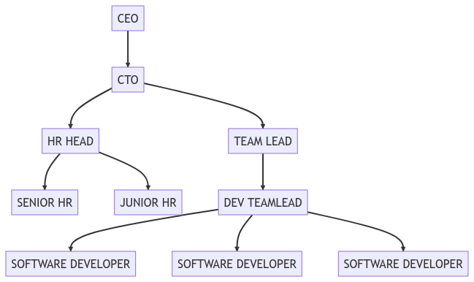

Fig 1.3.1 Organization Chart

## 1.4 CAPACITY OF PLANT

Currently, the company's capacity exceeds 180 personnel, and as part of its expansion efforts, it is actively adding new team members. It is anticipated that the company's workforce will reach or exceed 500 personnel in the future. The company's physical infrastructure can adequately accommodate up to 250 members, and as such, there is ample room for the expected increase in staff numbers. The expansion plans entail the addition of new members to various departments such as Website Development, UI/UX design, Mobile App Development, Quality Assurance, among others.

# CHAPTER 2 OVERVIEW OF DIFFERENT DEPARTMENT

## 2.1 WORK BEING CARRIED OUT IN EACH DEPARTMENT

### 2.1.1 E-Commerce - CMS Solutions

Cybercom provides consulting, design, and development services in the E-commerce department. They have excelled as one of the top Magento solution providers, having developed and launched over 700 successful E-commerce sites. Cybercom provides comprehensive services for the solid and long-term growth of your online business, whether it is B2C or B2B.

### 2.1.2 Mobile Application

The mobile application department at Cybercom Creation has successfully delivered over 100 mobile applications, showcasing their ability to build innovative and collaborative solutions. They specialize in developing customized and scalable mobile applications for both iOS and Android platforms. The team leverages cutting-edge technologies and follows a comprehensive development approach to deliver mobile applications that are user-friendly, intuitive, and responsive.

## 2.2 TECHNICAL SPECIFICATION

* Service
  + Web App Development
  + Mobile App Development
  + Testing and QA
* E-Commerce
  + Magento
  + Prestashop
  + OsCommerce
  + X-Cart
* Mobile
  + Android
  + IOS
* Framework
  + CakePhp
  + Codegniter
  + Microsoft .net MVC 3.0
* Cloud
  + AWS
  + Rackspace

## 2.3 SCHEMATIC PROCEDURE FOR MANUFACTURING A ECOMMERCE PROJECT

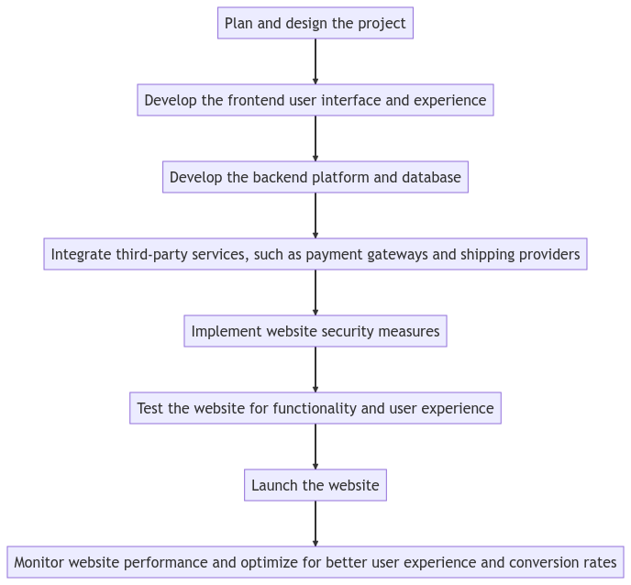

Fig 2.3.1 Project Scheduling

# CHAPTER 3 INTRODUCTION TO INTERNSHIP

## 3.1 INTERNSHIP SUMMARY

During my internship at Cybercom Creation, I gained practical experience in software development, learned new technical and soft skills, and completed projects that contributed to the company's products. As a backend developer in PHP during my internship I gained hands-on experience in developing robust and secure web applications, implemented new features to existing products, and collaborated with the team to ensure smooth deployment of the software.

As an intern gained valuable experience in backend development and learned about new industry standards and best practices and successfully contributed to the development of the e-commerce website project, particularly in the implementation of product categorization and secure payment processing features and also learned new programming concepts and best practices and applied them to improve code quality and efficiency. Throughout the internship, I completed assigned tasks and delivered high-quality work within the given timeframes. I demonstrated strong collaboration skills by actively participating in team meetings, providing updates on project progress, and supporting other team members as needed. As a result of my contributions, I received positive feedback from team members and supervisor on the quality of work and the impact of my contributions to the project.

In conclusion, my internship was a valuable learning experience that allowed me to develop my skills as a developer and gain practical experience in developing an e-commerce website. Through my work in the team, I was able to contribute to the development of the project and learned about new programming concepts and best practices. I also demonstrated strong collaboration skills and received positive feedback from my team members and supervisor. Overall, the internship provided me with a solid foundation in development and a greater understanding of the importance of teamwork and collaboration in software development projects. I am grateful for the opportunity and look forward to applying the skills and knowledge I gained in future endeavors.

## 3.2 PURPOSE

The purpose of my internship at Cybercom Creation was to gain practical experience in software development industry and contribute to the development of an e-commerce website project. Through this internship, I aimed to enhance my technical skills and gain a greater understanding of the software development process. Additionally, I wanted to develop my collaboration and communication skills by working with a team of experienced developers and learning from their expertise. Overall, the purpose of the internship was to gain real-world experience and knowledge that would help me in my future career as a developer.

The purpose of the project is to develop a fully functional online platform for selling products and services, catering to a wide range of customers. The project aims to provide an intuitive user interface for browsing and purchasing products, as well as secure payment processing and order management functionalities. The platform will incorporate modern web technologies and frameworks to ensure optimal performance across different devices and screen sizes. The project's ultimate goal is to provide a convenient and safe online shopping experience for customers and increase the revenue of the business.

## 3.3 OBJECTIVE

The main objective of Cyber Commerce project is to provide an e-commerce website platform that allows customers to browse and purchase products online, anytime and anywhere. The website aims to offer an intuitive user interface, easy navigation, and search functionalities to enhance the shopping experience for customers.

In addition, the project aims to develop a robust and secure website with SSL encryption and multiple payment gateways integrated for safe online transactions. The website will have a responsive design that ensures optimal performance across different devices and screen sizes.

Furthermore, the project includes the development of an admin panel that will allow the site administrator to manage the customer, catalog, sales, and generate reports. The admin panel will be designed with a bootstrap theme, providing a user-friendly interface and easy access to all data related to the site.

Overall, the objective of Cyber Commerce project is to create a user-friendly and secure e-commerce platform that meets the needs and expectations of customers, providing a seamless shopping experience.

## 3.4 SCOPE

**What you can do:**

* Develop a fully functional e-commerce website for selling products and services
* Build an intuitive user interface for browsing and purchasing products
* Implement secure payment processing and order management functionalities
* Integrate multiple payment gateways to provide convenient and secure payment options for customers
* Develop an admin panel with various sections for managing customer, catalog, sales, reports, etc.
* Ensure the website has a responsive design that performs optimally across different devices and screen sizes
* Use modern web technologies and frameworks to develop the website

**What you cannot do:**

* Develop features or functionalities that are beyond the scope of the project
* Deviate from the project's objectives and requirements
* Implement designs or functionalities that are not approved by the project manager or client
* Delay the project timeline without valid reasons or without consulting with the project manager or client
* Use unauthorized or unlicensed software, tools, or resources

## 3.5 TECHNOLOGY AND LITERATURE REVIEW

1. **PHP:**

PHP is a server-side scripting language used to develop dynamic web pages and web applications. It is widely used for developing e-commerce websites due to its scalability and security features.

1. **HTML:**

HTML stands for Hypertext Markup Language and is used for creating web pages. It provides a structure to the content of web pages and defines the layout and appearance of the content.

1. **CSS:**

CSS stands for Cascading Style Sheets and is used for styling web pages. It allows developers to control the layout and appearance of HTML content.

1. **JavaScript:**

JavaScript is a programming language used to create interactive and dynamic web pages. It is used for adding behavior to web pages, such as user input validation, animations, and page navigation.

1. **jQuery:**

jQuery is a JavaScript library that simplifies client-side scripting of HTML. It provides a variety of features, including DOM manipulation, event handling, and AJAX.

1. **AJAX:**

AJAX stands for Asynchronous JavaScript and XML and is a technique used to create asynchronous web applications. It allows web pages to update dynamically without requiring a page refresh.

1. **MySQL:**

MySQL is a popular open-source relational database management system used for storing and retrieving data. It is widely used in web development for storing data related to websites and web applications.

1. **Bootstrap:**

Bootstrap is a popular front-end framework for building responsive websites and web applications. It includes pre-designed HTML and CSS templates for various UI components, such as forms, buttons, navigation menus, and more. Bootstrap helps developers create consistent and user-friendly designs quickly and efficiently. It is based on HTML, CSS, and JavaScript and is open-source.

**9.Sublime**

Sublime is a text editor that is widely used by developers for writing and editing code. It has features like syntax highlighting, auto-completion, and customization options that make it a popular choice for web development.

**10.XAMPP**

XAMPP is a software package that includes Apache web server, MySQL database, and PHP interpreter, which are essential components for building and testing web applications. It provides a local development environment on a personal computer, making it easy for developers to work on their projects without needing to upload them to a live server.

**11.Git**

Git is a version control system used to track changes in source code during software development. It allows multiple developers to work on the same codebase simultaneously and merge their changes seamlessly. Git is widely used in the industry and has become an essential tool for software development teams.

### 3.5.2 Literature Review

The literature review for this project focused on studying various existing e-commerce websites, including Amazon, Flipkart, Myntra, Ajio, and others. The purpose was to analyze their features and drawbacks to identify best practices and areas for improvement in the development of Cyber Commerce.

1. **Amazon:**

* **Features:** Wide range of products, fast delivery, easy returns and refunds, personalized product recommendations, Amazon Prime membership for additional benefits.
* **Drawbacks:** High competition from other sellers, some products may be of lower quality from third-party sellers, counterfeit products may be sold.

1. **Flipkart:**

* **Features**: vast product range, easy returns and exchanges, fast and reliable delivery, user-friendly interface, various payment options, customer reviews and ratings.
* **Drawbacks:** quality control issues, fake reviews, poor customer service, frequent website crashes, product delivery delays.

1. **Myntra:**

* **Features**: huge selection of clothing and accessories, easy returns and exchanges, user-friendly interface, multiple payment options, customer reviews and ratings.
* **Drawbacks**: high pricing, limited product range (only clothing and accessories), poor customer service, frequent website crashes.

Overall, while these ecommerce sites have their unique features and advantages, they also have their own set of drawbacks and limitations. It is important to consider all of these factors when building an ecommerce website in order to provide the best possible user experience and address common issues faced by customers.

## 3.6 PROJECT PLANNING

### 3.6.1 Project Development Approach and Justification

For the development of Cyber Commerce, we used the agile methodology which involved the following steps:

1. Planning and setting the goals for the project
2. Breaking down the project into smaller tasks and prioritizing them
3. Assigning the tasks to the team members
4. Developing and testing the features incrementally
5. Reviewing the progress regularly and making necessary changes to meet the project goals.

Using agile methodology helped us to complete the project efficiently and effectively, by providing a flexible and iterative approach to the development process.

### 3.6.2 Project Effort and Time, Cost Estimation

Here are the steps for project effort and time, cost estimation in the context of Cyber Commerce:

1. Identify project requirements: The first step is to identify the project requirements, including functional and non-functional requirements.
2. Determine project scope: Define the scope of the project, including the features and functionalities of Green Mart.
3. Develop work breakdown structure (WBS): Break down the project into smaller, more manageable tasks using a work breakdown structure.
4. Estimate task duration: Estimate the amount of time each task will take, based on historical data or expert judgment.
5. Estimate resource requirements: Determine the resources required for each task, including personnel, equipment, and materials.
6. Develop project schedule: Develop a project schedule that outlines the start and end dates for each task, as well as the overall project timeline.
7. Estimate project cost: Estimate the project cost by determining the cost of each resource required for the project, as well as any other expenses such as equipment or software.
8. Monitor project progress: Continuously monitor the project's progress and adjust the schedule and cost estimates as necessary.

By following these steps, the project team can effectively estimate the effort and time required to complete Green Mart, as well as the associated costs.

### 3.6.3 Roles and Responsibilities

In the context of Cyber Commerce project, the following are the roles and responsibilities:

1. Project Manager: responsible for planning, coordinating, and executing the project, ensuring that it meets its objectives, and monitoring project progress.
2. Front-end Developer: responsible for designing and developing the user interface of the website using HTML, CSS, JavaScript, and jQuery.
3. Back-end Developer: responsible for developing the server-side of the application using PHP, MySQL, and other related technologies.
4. Quality Assurance Engineer: responsible for testing the website's functionality, performance, and security to ensure that it meets the project's requirements.
5. Database Administrator: responsible for maintaining the database and ensuring that it is reliable, secure, and efficient.
6. Content Creator: responsible for creating and managing the website's content, including product descriptions, images, and other relevant information.
7. Technical Writer: responsible for creating project documentation, including user manuals, technical specifications, and other relevant documents.
8. System Administrator: responsible for managing the website's server, ensuring that it is reliable, secure, and performs optimally.

Each team member has a crucial role in ensuring the project's success, and their responsibilities are clearly defined to ensure that they work cohesively towards achieving the project's objectives.

### 3.6.4 Group Dependencies

In the development of Green Mart, there were several group dependencies that needed to be considered:

1. **Development team**: The development team was responsible for designing and implementing the website, including the front-end and back-end development.
2. **Testing team**: The testing team was responsible for ensuring that the website was functioning properly and meeting the project requirements.
3. **Content team**: The content team was responsible for creating and managing the content on the website, including product descriptions, images, and other information.
4. **Design team**: The design team was responsible for creating the overall look and feel of the website, including the layout, color scheme, and user interface.
5. **Marketing team**: The marketing team was responsible for promoting the website and attracting customers through various channels, such as social media, email marketing, and advertising.
6. **Management team**: The management team was responsible for overseeing the entire project, ensuring that it was completed on time and within budget, and making key decisions throughout the development process.

## 3.7 PROJECT SCHEDULING (GANTT CHART)

An elementary Gantt chart or Timeline chart for the development plan is given below.

The plan explains the tasks versus the time (in weeks) they will take to complete.

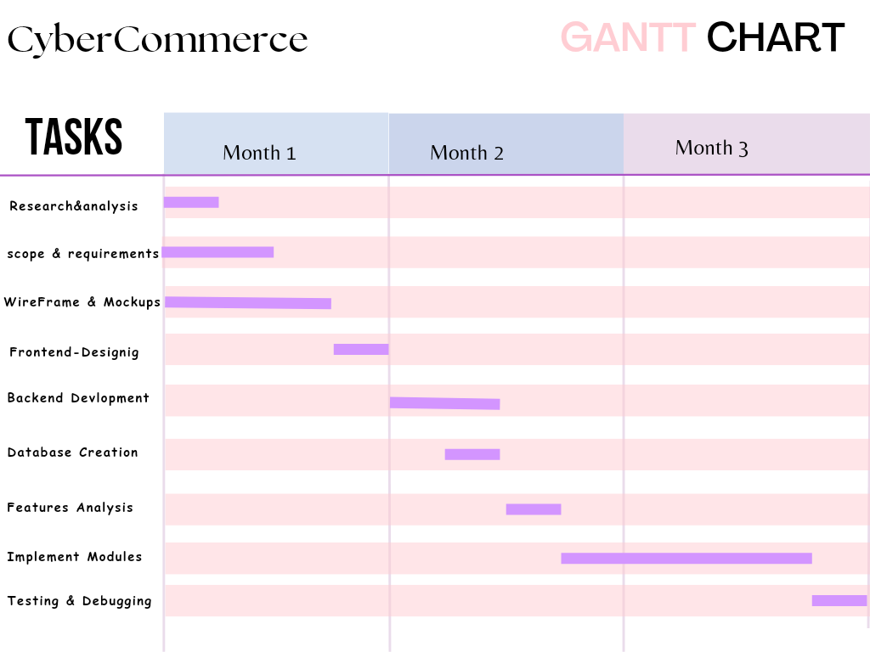

Fig 3.7.1 Gantt Chart

# CHAPTER 4 SYSTEM ANALYSIS

## 4.1 STUDY OF CURRENT SYSTEM

Ecommerce, or electronic commerce, is the buying and selling of goods or services over the internet. In recent years, the ecommerce industry has experienced significant growth, and the current system of ecommerce has evolved to become more efficient and user-friendly.

One of the main components of the current system of ecommerce is the online marketplace. Online marketplaces are platforms that connect buyers and sellers, allowing them to transact business over the internet. Popular online marketplaces include Amazon, eBay, and Alibaba.

Another important aspect of ecommerce is the payment processing system. Payment processors like PayPal, Stripe, and Square enable buyers to securely make purchases using their credit or debit cards, while also protecting their sensitive financial information.

Logistics and shipping are also key components of the current system of ecommerce. Ecommerce companies often partner with third-party logistics providers (3PLs) to manage the storage, transportation, and delivery of goods. These 3PLs can help ecommerce companies to streamline their supply chain processes, reduce costs, and improve delivery times.

## 4.2 PROBLEM AND WEAKNESSES OF CURRENT SYSTEM

Cybersecurity: Ecommerce transactions involve the exchange of sensitive information such as credit card numbers, addresses, and personal details. As a result, the risk of cyberattacks and data breaches is a major concern for ecommerce businesses and consumers alike.

Shipping and logistics: Despite improvements in logistics and shipping, many ecommerce companies still struggle with issues such as shipping delays, incorrect or damaged shipments, and high shipping costs. These issues can lead to customer dissatisfaction and lost sales.

Returns and refunds: Ecommerce companies often have complex return and refund policies that can be difficult for consumers to navigate. This can result in frustration and a lack of trust in the ecommerce business.

Lack of physical interaction: One of the key benefits of traditional brick-and-mortar stores is the ability to physically interact with products before making a purchase. Ecommerce businesses are often unable to offer this experience, which can lead to lower sales and customer satisfaction.

Platform monopolies: A few dominant online marketplaces, such as Amazon and Alibaba, have significant control over the ecommerce industry. This can lead to limited competition and reduced innovation, as smaller businesses struggle to compete.

Environmental impact: The growth of ecommerce has led to an increase in packaging waste and carbon emissions from shipping. This can have a negative impact on the environment.

## 4.3 REQUIREMENTS OF NEW SYSTEM

**Stronger cybersecurity:** The new ecommerce system should prioritize the security of customer data by implementing advanced cybersecurity measures to prevent cyberattacks and data breaches.

**Improved logistics and shipping:** The new ecommerce system should prioritize efficient and cost-effective logistics and shipping to ensure timely delivery of products while keeping costs low for both the business and the customer.

**Streamlined returns and refunds:** The new ecommerce system should provide consumers with an easy and transparent returns and refunds process to improve customer satisfaction and trust.

**Enhanced customer experience:** The new ecommerce system should provide customers with an engaging and personalized shopping experience, such as allowing them to interact with products virtually, chat with customer service representatives, and receive personalized recommendations based on their preferences.

**Increased competition:** The new ecommerce system should encourage healthy competition and innovation by supporting small and medium-sized businesses and preventing monopolies by dominant players in the market.

**Sustainable practices:** The new ecommerce system should prioritize sustainability by reducing packaging waste and carbon emissions from shipping, promoting eco-friendly packaging, and encouraging responsible sourcing and production practices.

## 4.4 SYSTEM FEASIBILITY

**4.4.1 Does the system contribute to the overall objectives of the organization?**

The extent to which the ecommerce system contributes to the overall objectives of an organization depends on the specific goals and priorities of that organization. However, in general, the ecommerce system can contribute to the overall objectives of an organization in several ways:

**Increased revenue:** Ecommerce can significantly increase an organization's revenue by expanding its customer base and providing customers with convenient and accessible ways to purchase products or services.

**Cost savings:** Ecommerce can also help an organization to save costs by reducing the need for physical stores and associated expenses such as rent, utilities, and staffing.

**Improved customer satisfaction:** A well-designed ecommerce system can provide customers with a seamless and personalized shopping experience, leading to increased customer satisfaction and loyalty.

**Data-driven insights:** The ecommerce system can also provide an organization with valuable data and insights into customer behaviour and preferences, enabling it to make data-driven decisions that improve its overall performance.

**Global reach:** Ecommerce can help an organization to expand its reach beyond traditional geographic boundaries, allowing it to reach customers worldwide and tap into new markets.

**4.4.2 Can the system be implemented using the current technology and within the given cost and schedule constraints.**

The feasibility of implementing the ecommerce system within the given technology, cost, and schedule constraints will depend on several factors, such as the complexity of the system, the availability of suitable technology, the expertise of the development team, and the resources available to the organization.

If the organization has a team of experienced developers with the necessary skills and expertise, and the required technology is readily available, then it is possible to implement the ecommerce system within the given constraints. However, if the technology is not readily available, or the development team lacks the necessary expertise, then the cost and schedule may be impacted.

Additionally, the complexity of the ecommerce system may also affect the cost and schedule. A more complex system may require more resources and time to develop, leading to increased costs and a longer development schedule.

Therefore, before implementing the ecommerce system, it is important for the organization to conduct a feasibility study to assess the cost and schedule requirements and ensure that the available technology and expertise are sufficient to implement the system within the given constraints.

**4.4.3 Can the system be integrated with other systems which are already in place?**

The ability to integrate the ecommerce system with other systems that are already in place will depend on several factors, such as the compatibility of the technology used in the ecommerce system and the existing systems, the data formats used by the systems, and the availability of APIs and other integration tools.

If the technology used in the ecommerce system is compatible with the existing systems, and the data formats used by the systems are compatible, then it should be possible to integrate the ecommerce system with the other systems. Additionally, if APIs or other integration tools are available, this can simplify the integration process and make it easier to connect the ecommerce system with the other systems.

However, if the technology used in the ecommerce system is not compatible with the existing systems, or the data formats used by the systems are not compatible, then it may be difficult or even impossible to integrate the ecommerce system with the other systems.

Therefore, it is important for the organization to conduct a thorough analysis of the existing systems and their compatibility with the ecommerce system before attempting to integrate them. This analysis will help to identify any potential compatibility issues and determine the feasibility of integrating the ecommerce system with the other systems.

## 4.5 PROPOSED SYSTEM

When a new project is proposed, it normally goes through feasibility assessment. Feasibility study is carried out to determine whether the proposed system is possible to develop with available resources and what should be the cost consideration. Facts considered in the feasibility analysis were.

* Technical Feasibility
* Economic Feasibility
* Behavioural Feasibility

## 4.6 FEATURES OF PROPOSED SYSTEM

* Product catalog with descriptions, prices, and availability
* Shopping cart for customers to add products and proceed to checkout
* Secure payment processing options
* Shipping and delivery options for customers to select their preferred method
* Customer service portal or chatbot for assistance
* Built-in marketing and promotional tools
* Analytics and reporting tools for tracking sales and customer behaviour

## 4.7 LIST OF MAIN MODULES

* Product Management: This module includes functions for adding, editing, and managing products, including their descriptions, images, prices, and inventory.
* Order Management: This module handles the processing of orders, including order tracking, payment processing, and shipping management.
* Customer Management: This module manages customer accounts, including customer registration, account login, and account details.
* Marketing Management: This module includes tools for managing promotions, discounts, coupons, and other marketing campaigns to attract and retain customers.
* Payment Management: This module handles payment processing, including the integration of payment gateways and transaction management.
* Shipping Management: This module handles shipping and delivery options, including tracking of shipments and management of shipping providers.
* Analytics and Reporting: This module provides data analytics and reporting tools for tracking sales, customer behaviour, and other key performance indicators (KPIs).
* Security Management: This module includes functions for managing security features, such as user authentication, data encryption, and SSL certificates.
* Content Management: This module manages the content of the ecommerce system, including product descriptions, images, and other marketing materials.

## 4.8 SELECTION OF HARDWARE / SOFTWARE

**Software Requirement**

The S/W for developing and deployment of this project was

* Xampp
* MySQL
* Git
* GitHub
* Sublime Text

**Hardware Requirement**

The H/W for developing and deployment of this project was

* 8GB Ram
* i5 or equivalent processor
* SSD (preferable)
* Server

# CHAPTER 5 SYSTEM DESIGN

## 5.1 SYSTEM DESIGN & METHODOLOGY

### 5.1.1 Use Case Diagram

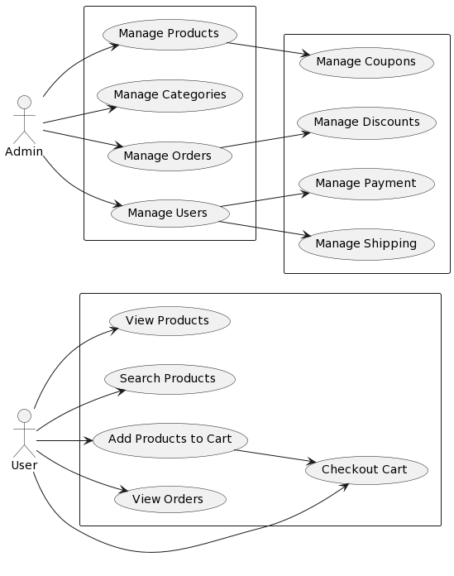

Fig 5. 1.1.1 Use Case Diagram

Fig 4. 1.1.1 Use Case Diagram

Fig 1. Fig 4. 1.1.1 Use Case Diagram

Fig 5.1.1 Use Case Diagram

Fig 5.1.1.1 Use Case Diagram

### 5.1.2 Activity Diagram

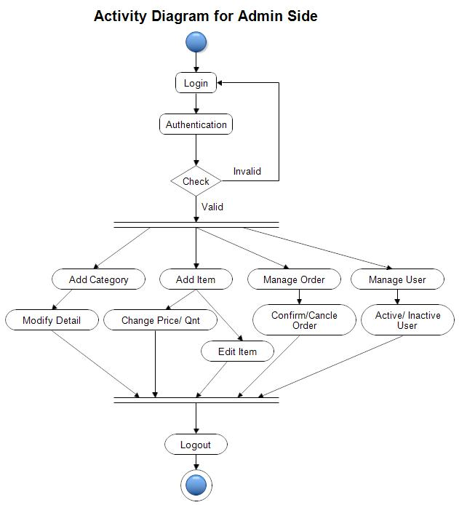

Fig 5.1.2.1 Activity Diagram

### 5.1.3 Sequence Diagrams

**5.1.3.1 Product Module**

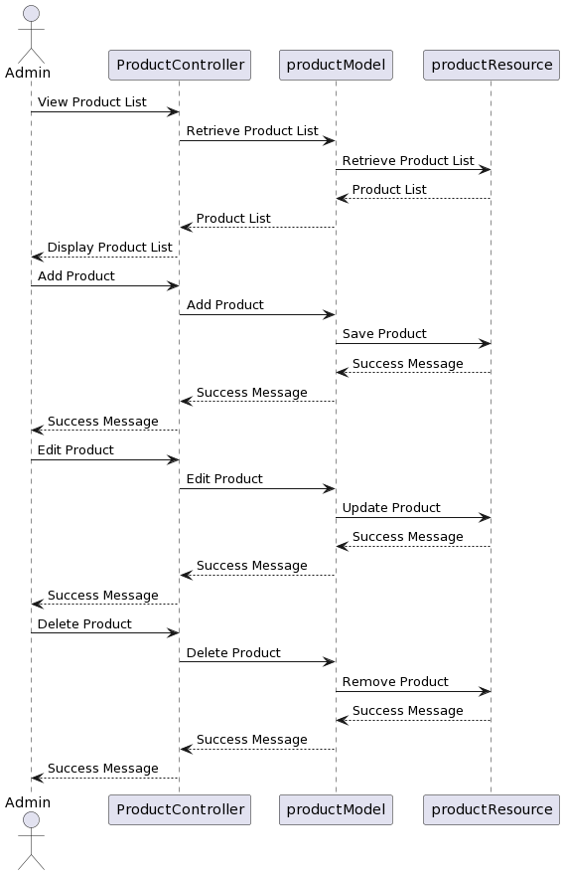

Fig 5.1.3.1 Sequence Diagram of Product Module

**5.1.3.2 Eav Attribute Module**

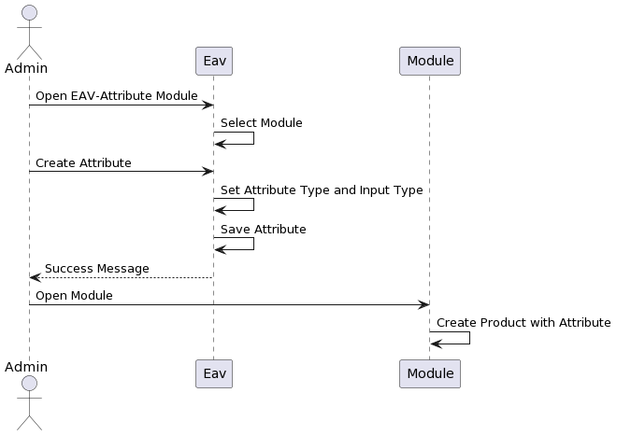

Fig 5.1.3.2 Sequence Diagram of Eav Attribute Module

**5.1.3.3 Quote Module**

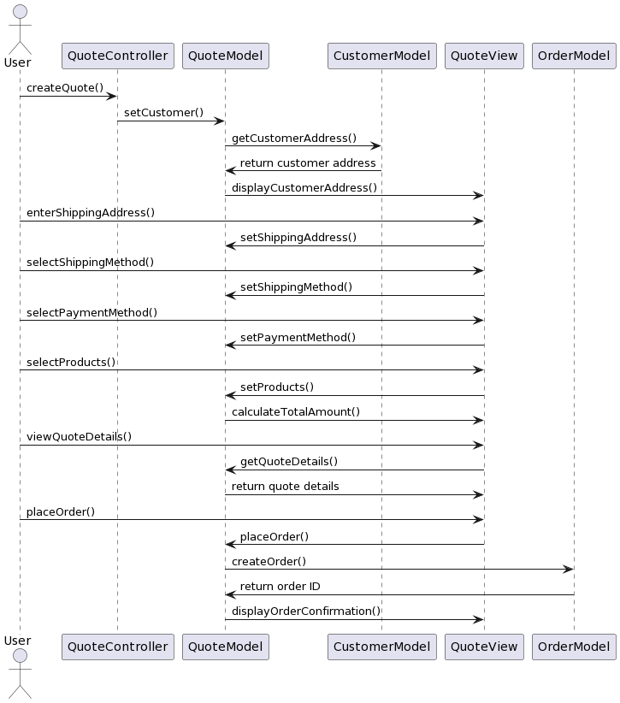

Fig 5.1.3.3 Sequence Diagram for Quote Module

## 5.2 DATABASE DESIGN

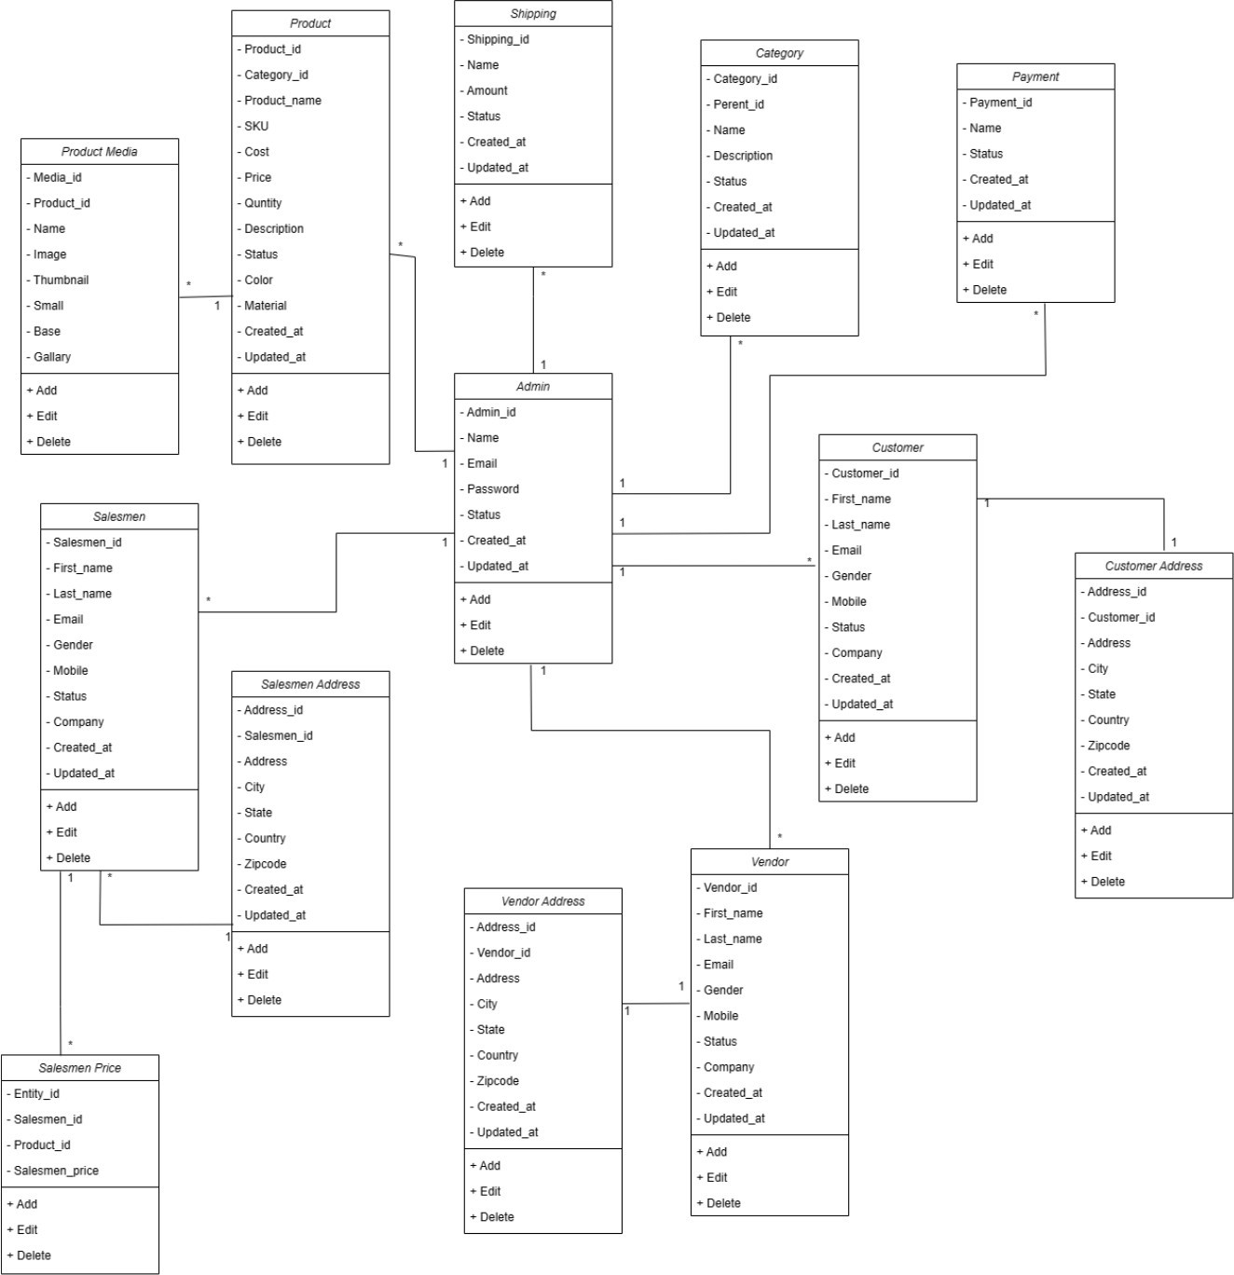

Fig 5.2.1 Database Design

## 5.3 INTERFACE DESIGN

5.3.1 State Transition Diagram

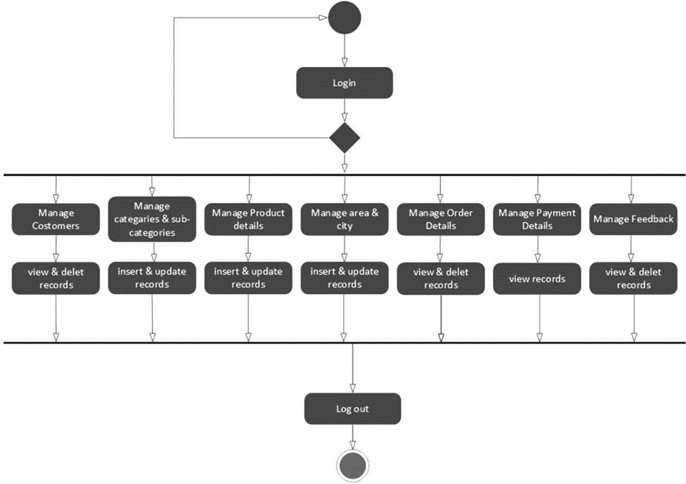

Fig 5.3.1 State Transition Diagram

5.3.2 Samples of Forms, Reports and Interface

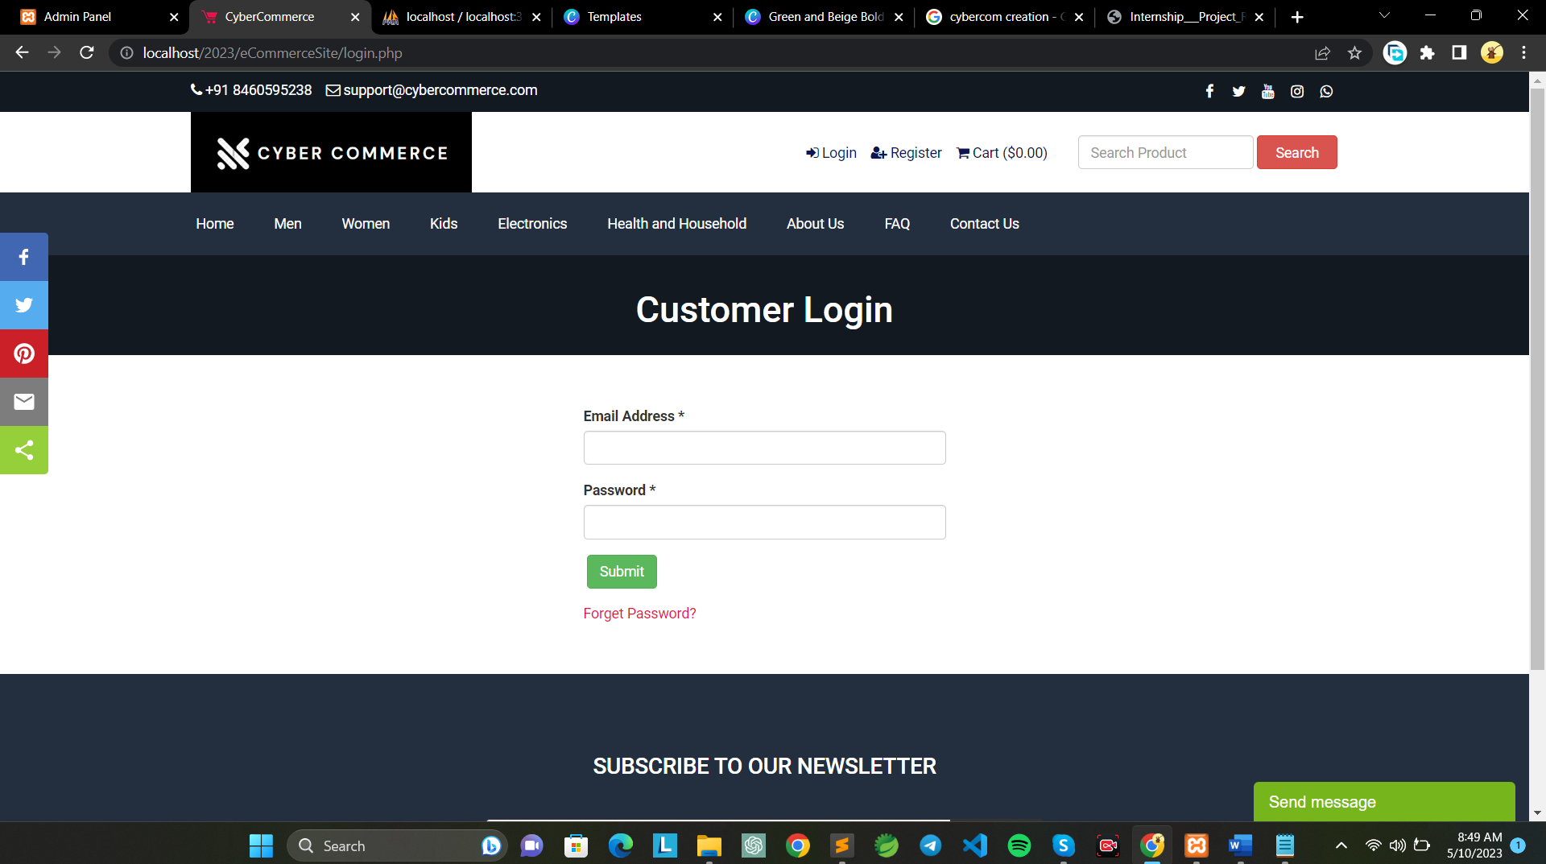

Fig 5.3.2.1 Customer Login

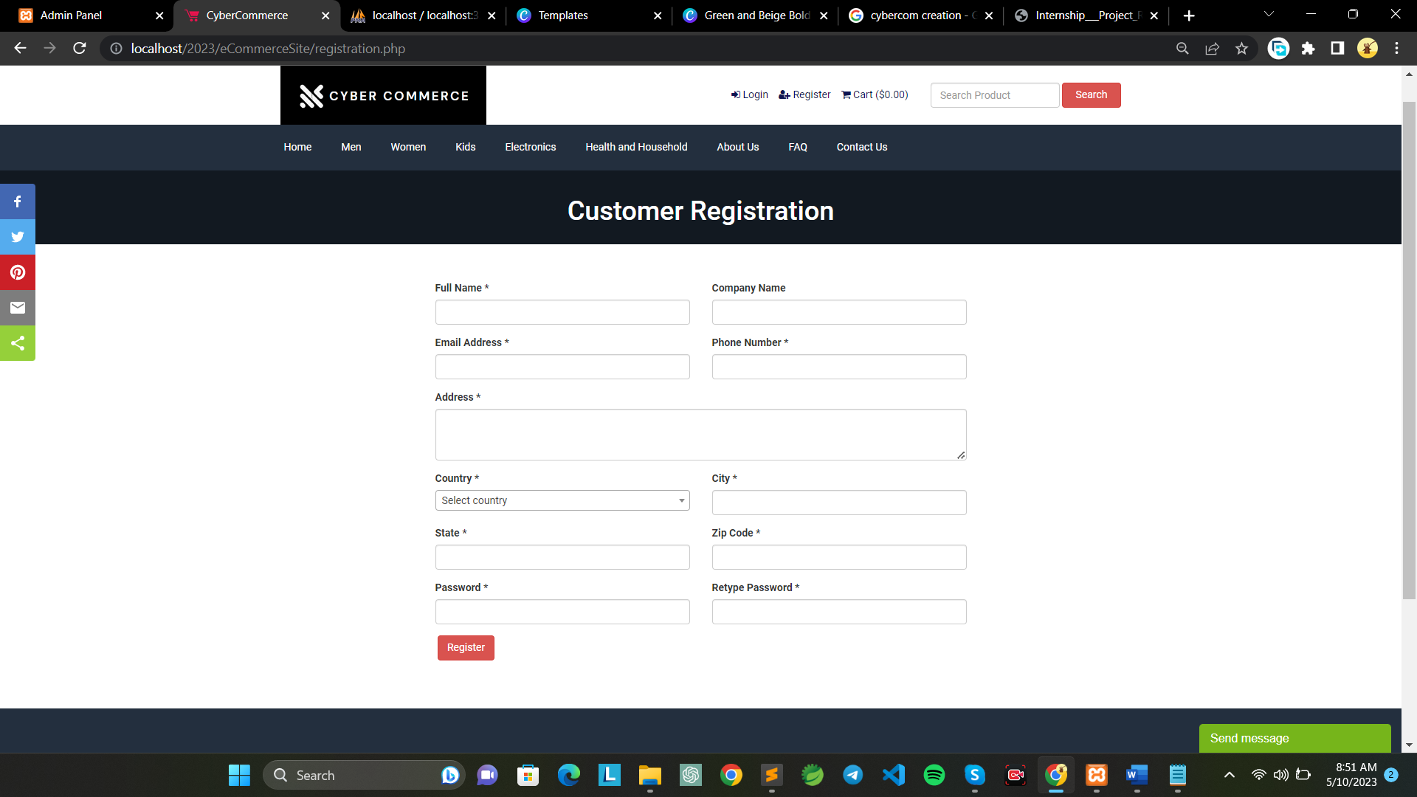

Fig 5.3.2.2 Customer Registration

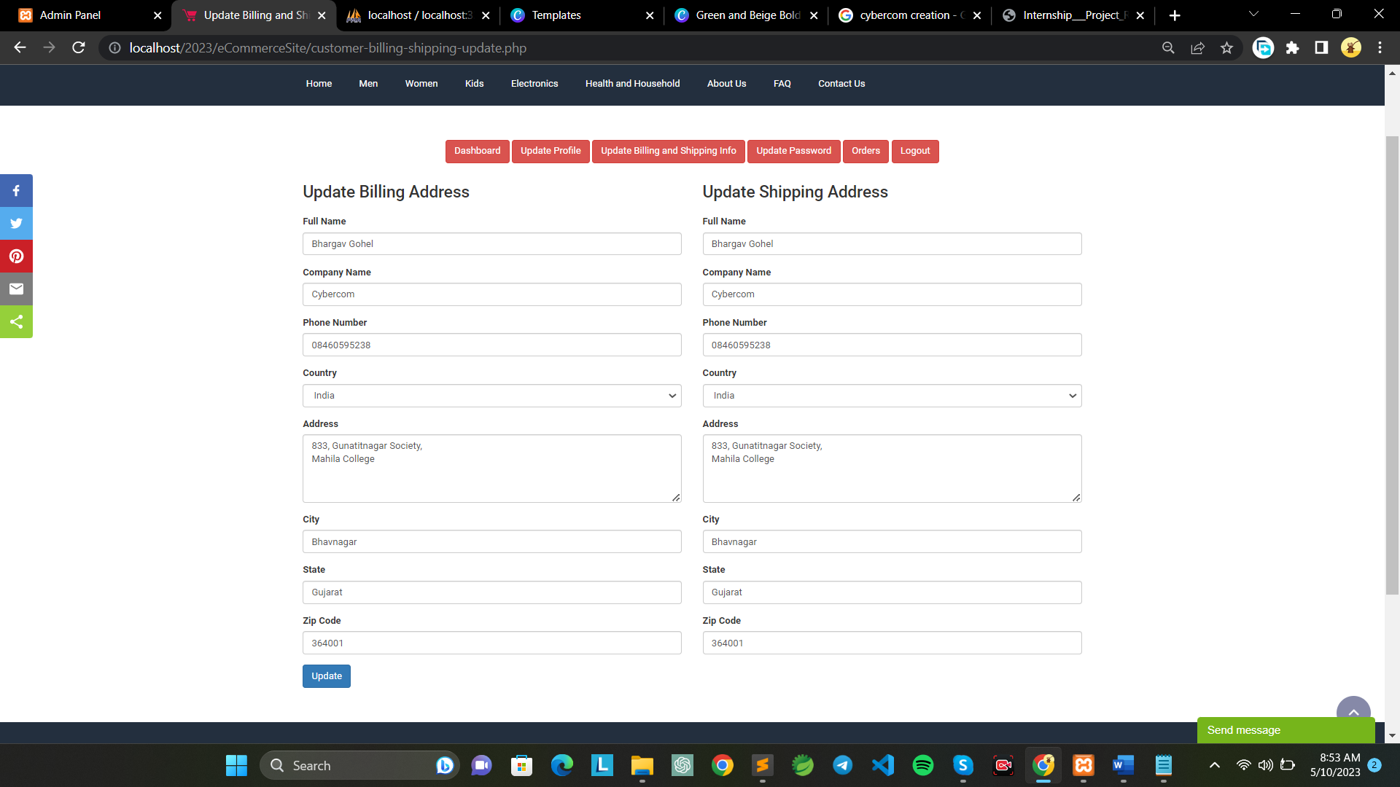

Fig 5.3.2.3 Update Customer Address

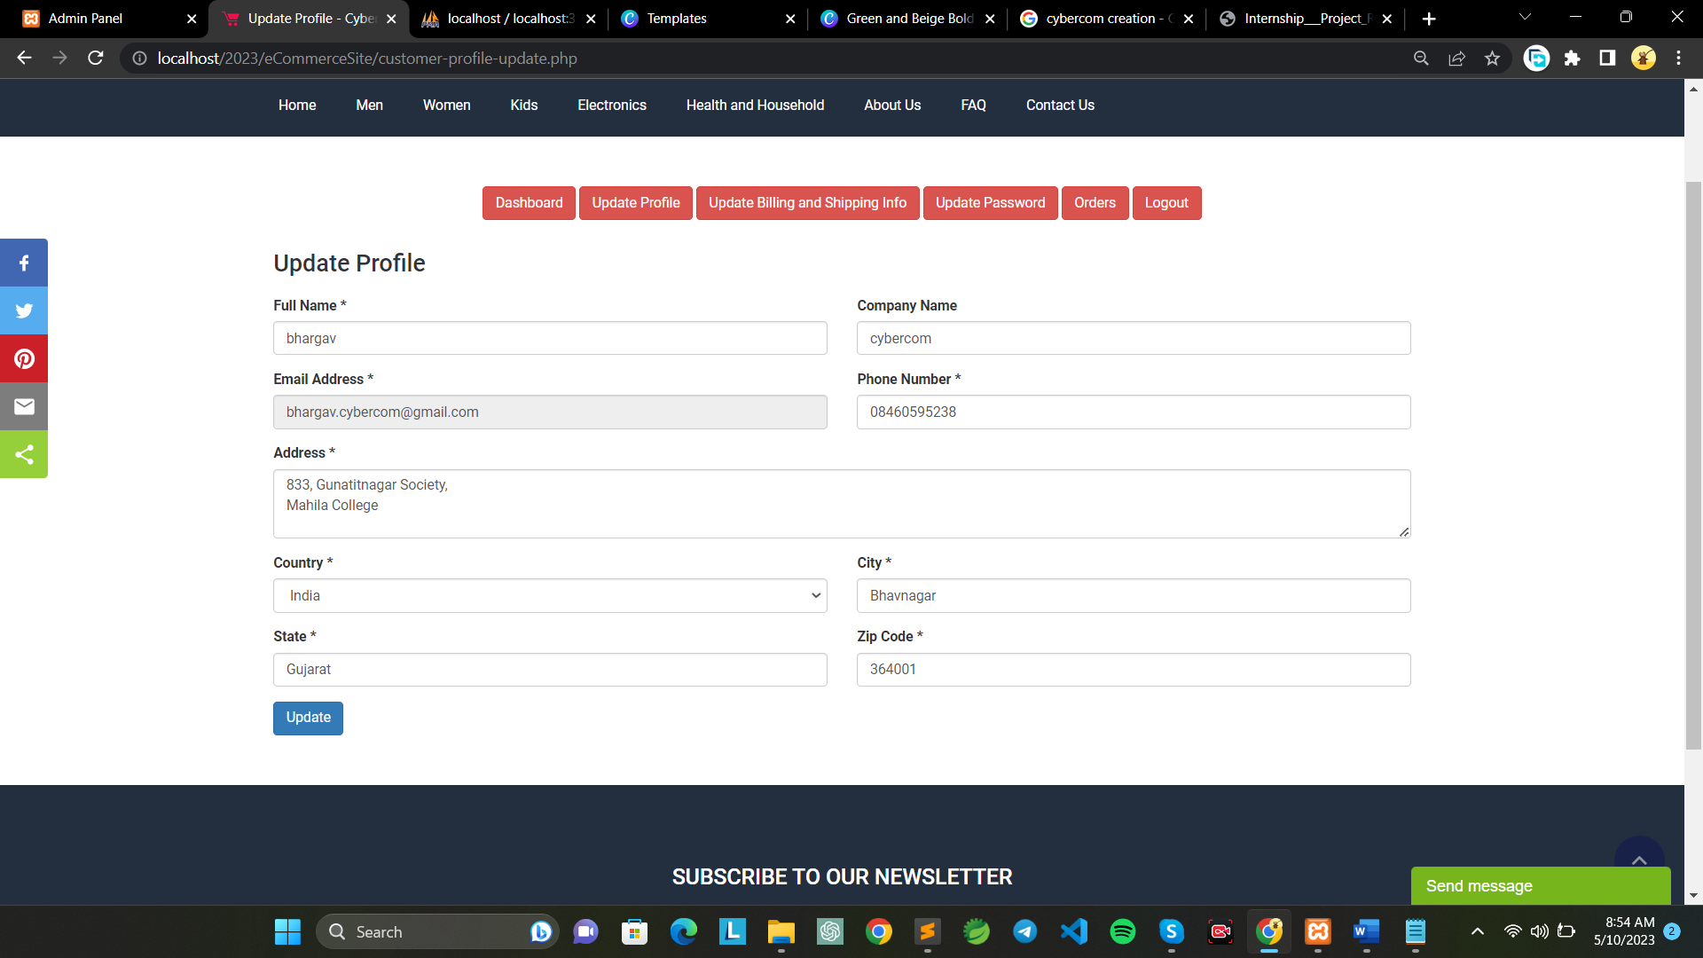

Fig 5.3.2.4 Update Profile

# CHAPTER 6 IMPLEMENTATION

## 6.1 IMPLEMENTATION PLATFORM

Cybercommerce is an ecommerce project built using PHP with MySQL database connectivity. The project allows users to browse and search for products, view pricing details, add products to their cart, and place orders. The admin can verify and manage orders, and customers receive their orders in a few days. The project was built using a XAMPP stack (Windows, Apache, MySQL, PHP), with HTML, CSS, and JavaScript used for the front-end. The project was developed using a local development environment before being deployed to a hosting provider. The project implements basic security measures, such as input validation and password hashing. As future enhancements, the project could include additional features such as user accounts, payment processing, shipping integration.

## 6.2 PROCESS AND TECHNOLOGY

Define project scope and requirements: Identify the objectives of the project, define the scope, and gather requirements for the ecommerce website. Choose the technology stack: Select the technology stack for developing the website, such as PHP for the server-side scripting language and MySQL for the database. Develop the website: Create the website's structure and user interface, design the database schema, and write the code for the website's functionality. Test the website: Perform functional testing, integration testing, and user acceptance testing to ensure the website is bug-free and user-friendly. Deploy the website: Deploy the website on a web server and configure it for production use. Maintain the website: Regularly update the website with new features, fix bugs, and improve performance to keep it running smoothly. Train users: Provide training to the website users on how to use the website, especially the admin, to manage orders and update product information.

The tools and technologies which is used in this project is as below:

* Front-end: HTML, CSS, JavaScript
* Back-end: PHP, MySQL
* Web server: Apache
* Operating system: Windows

## 6.3 RESULTS

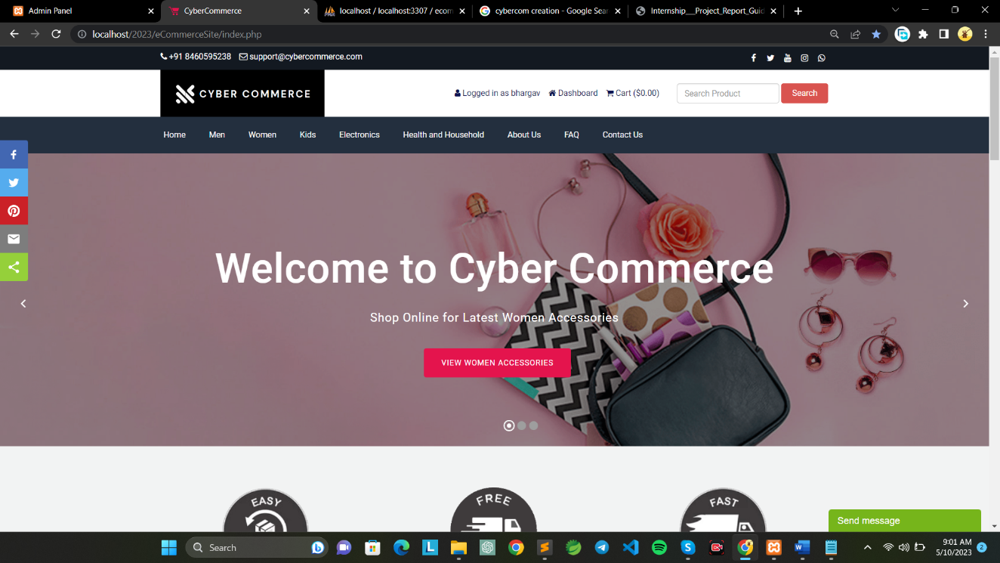

Fig 6.3.1 Home Screen

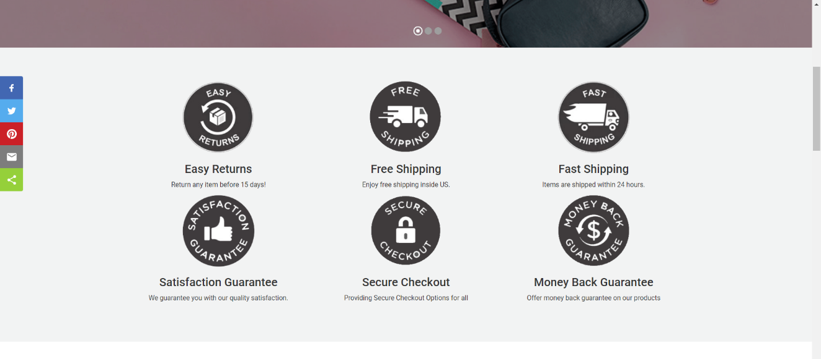

Fig 6.3.2 Services

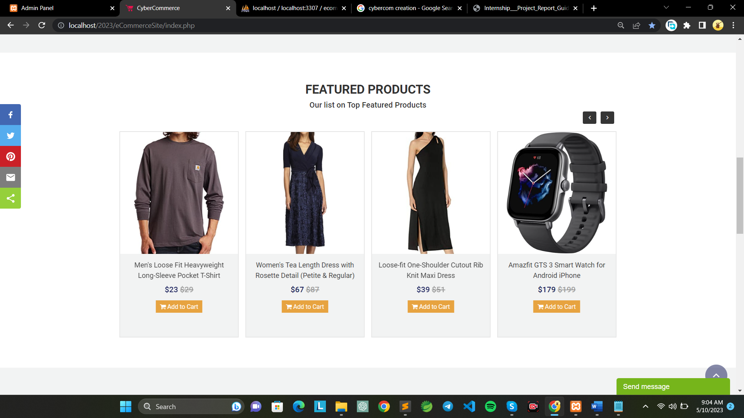

Fig 6.3.3 Featured Products

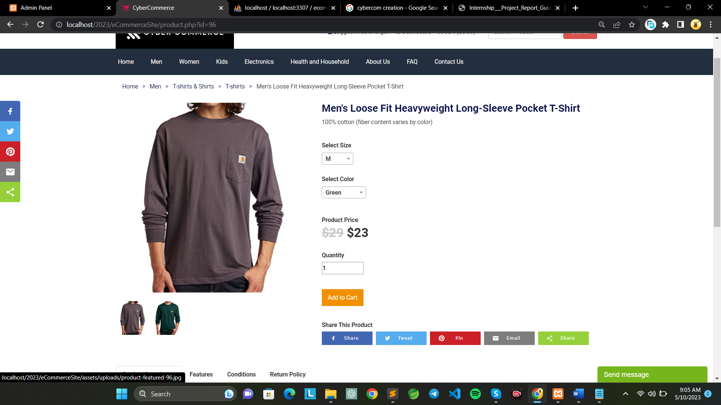

Fig 6.3.4 Product View

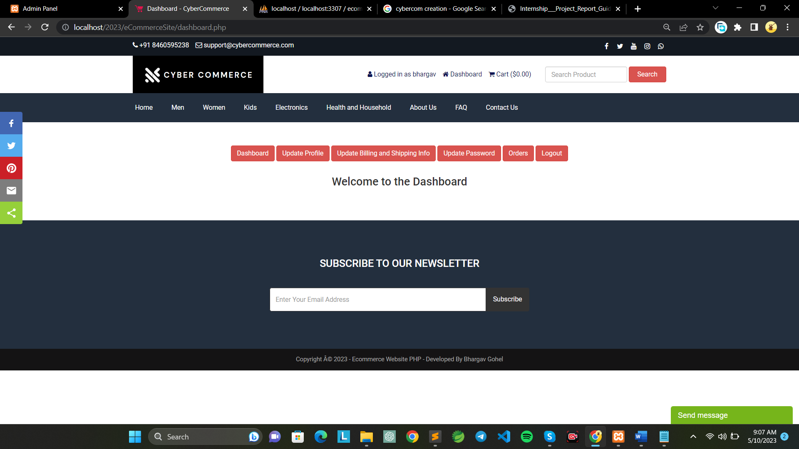

Fig 6.3.5 Customer Dashboard

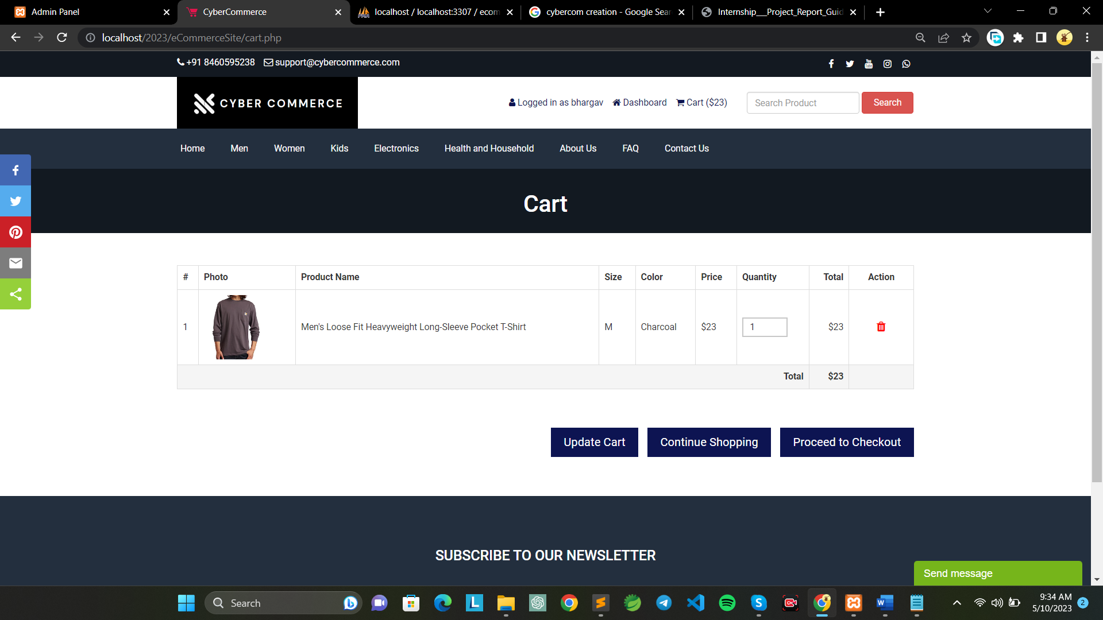

Fig 6.3.6 Cart

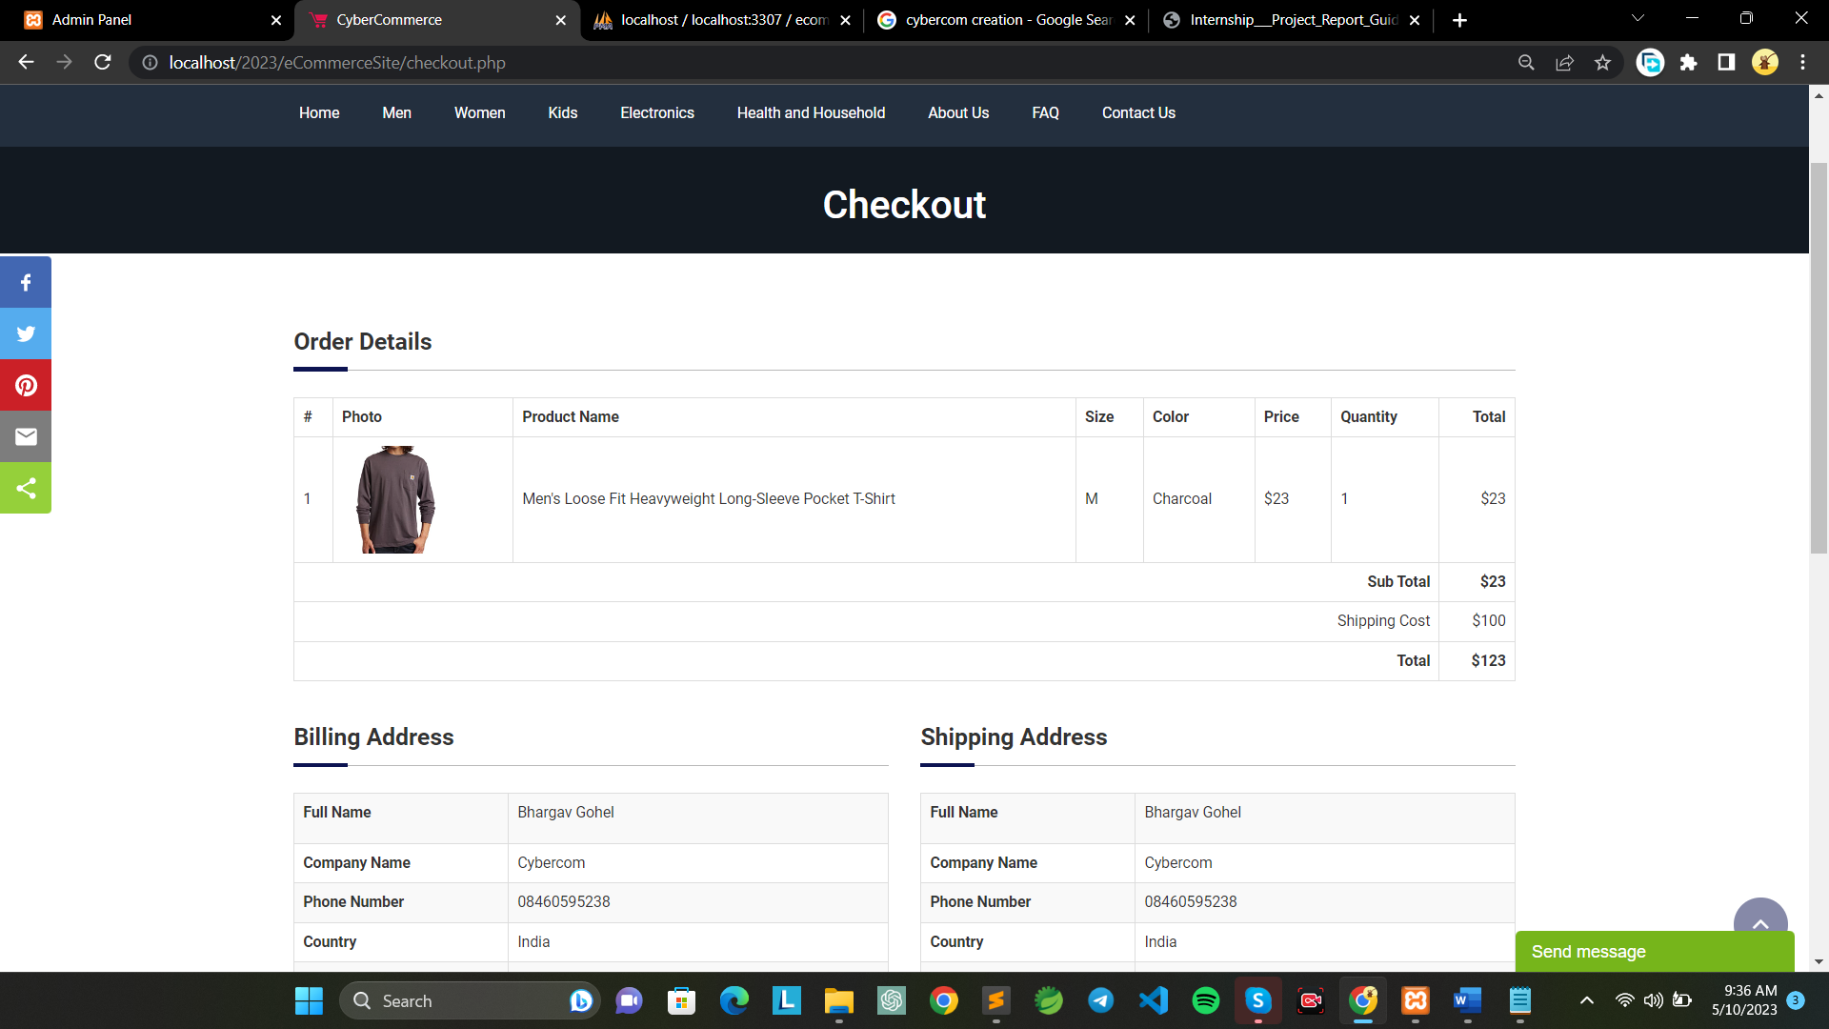

Fig 6.3.7 Checkout

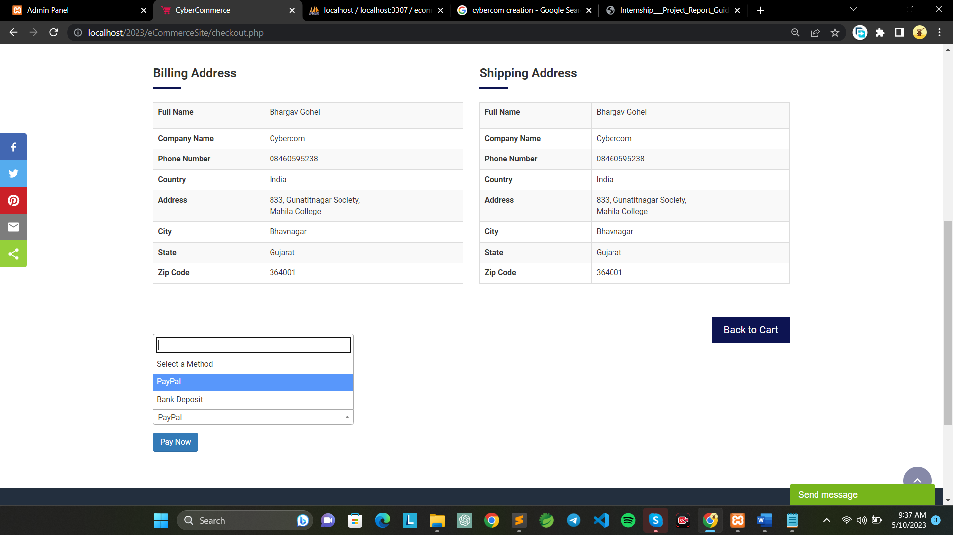

Fig 6.3.8 Payment Method

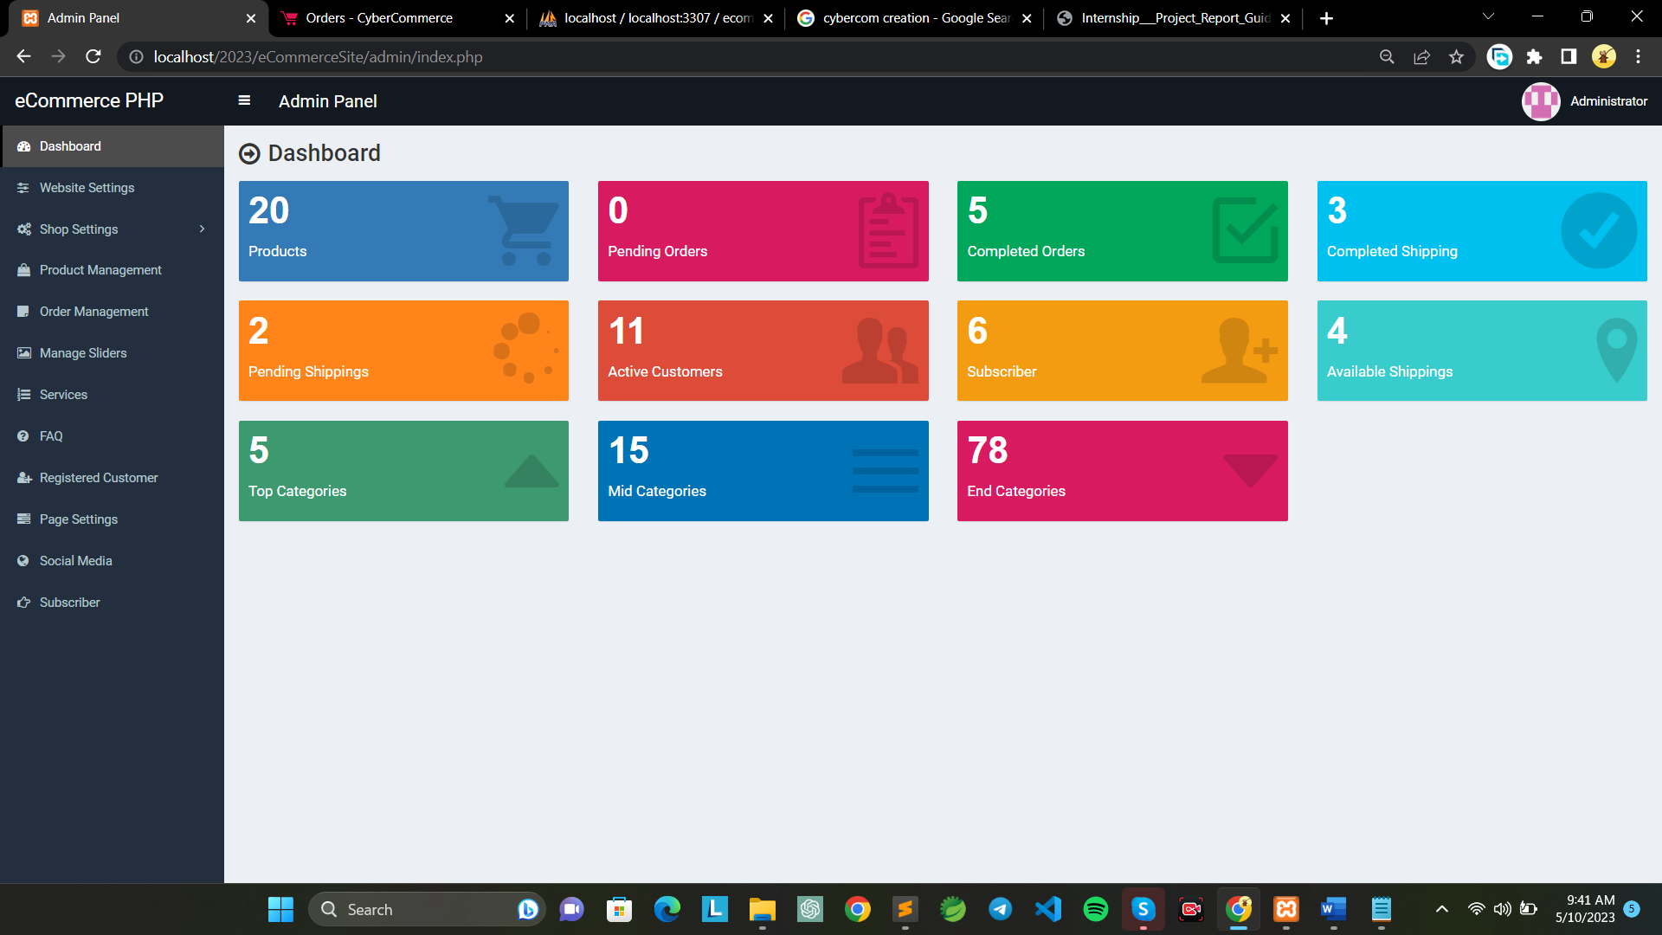

Fig 6.3.9 Admin Panel

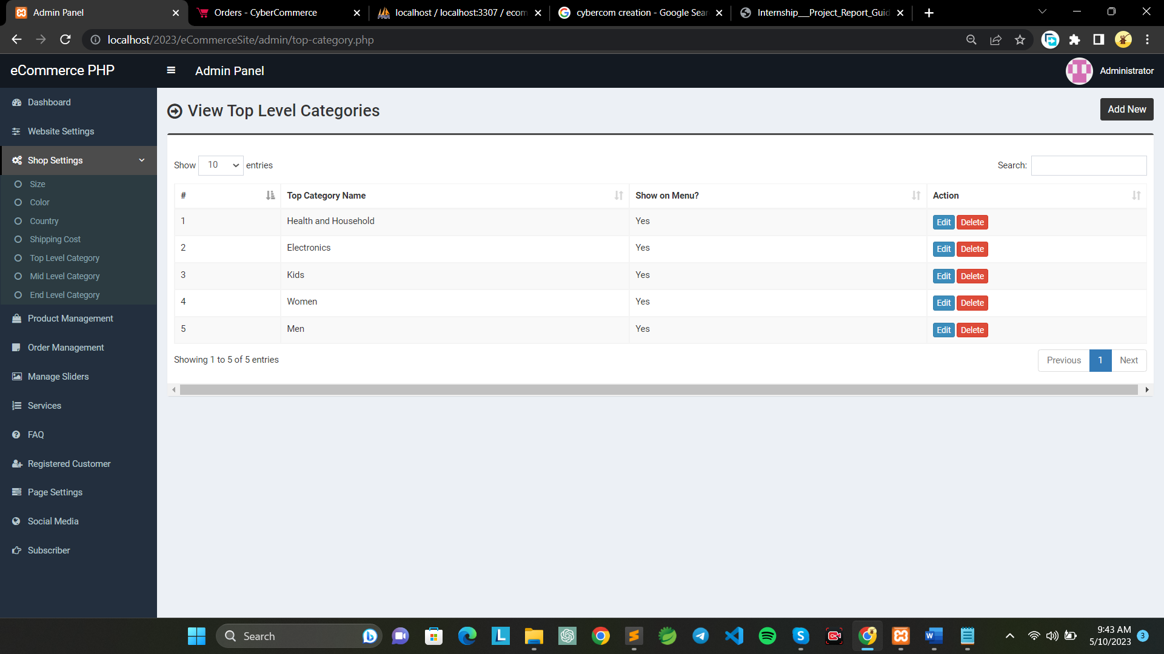

Fig 6.3.10 Manage Category

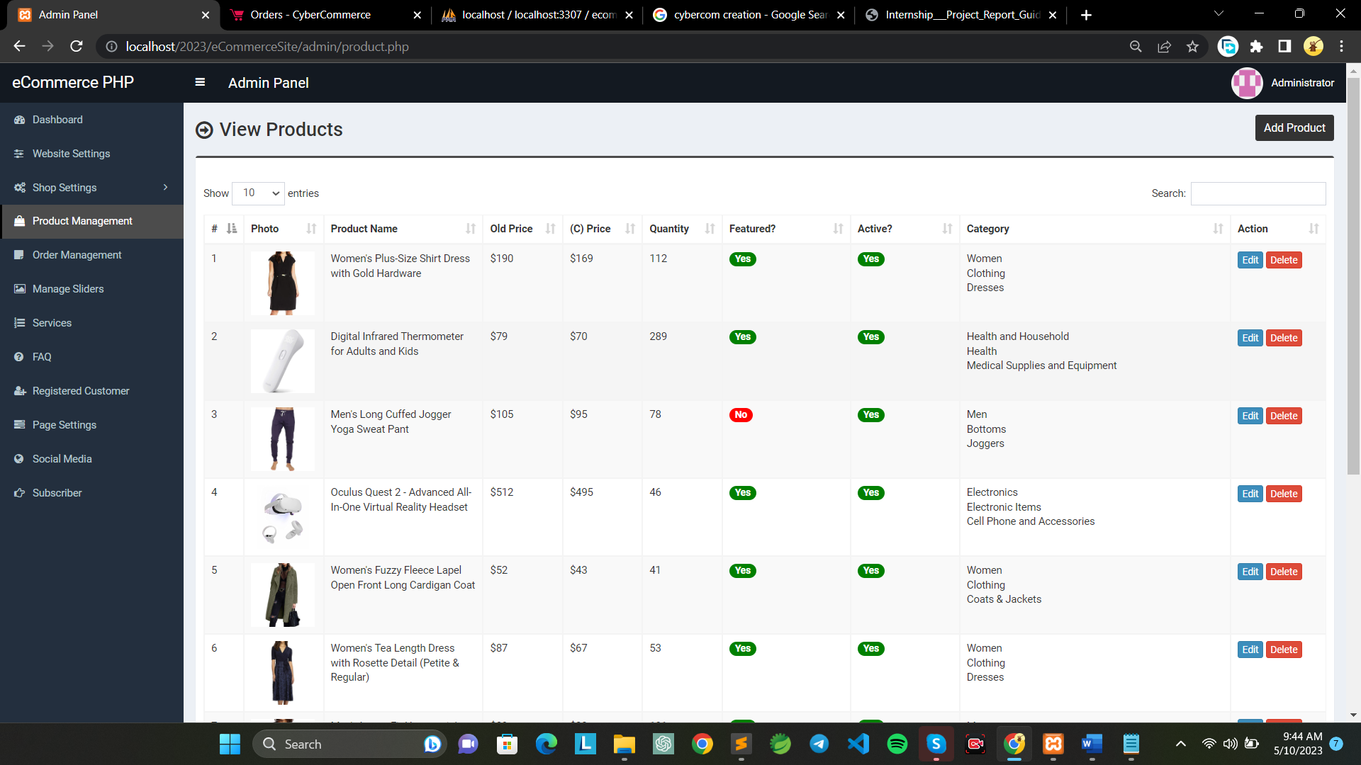

Fig 6.3.11 Manage Products

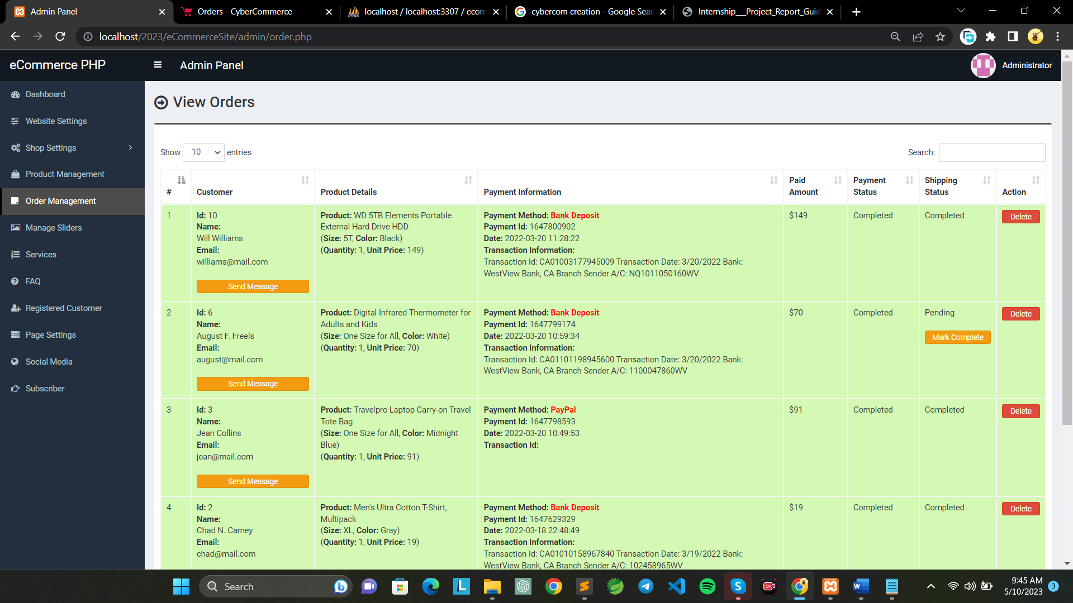

Fig 6.3.12 Manage Orders

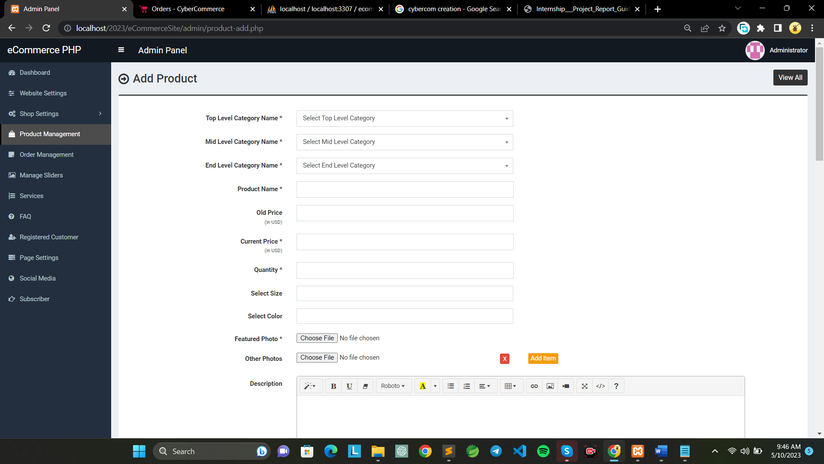

Fig 6.3.13 Add Product

# CHAPTER 7 TESTING

## 7.1 TESTING PLAN / STRATEGY

Testing is an important phase in the software development life cycle (SDLC) to ensure that the system functions as expected and meets the specified requirements. A testing plan or strategy outlines the approach to be taken for testing the software and the various types of tests to be performed.

For our ecommerce project, the testing plan/strategy can include the following points:

* A testing plan that outlines the scope, objectives, and approach to testing the e-commerce website.
* Test cases for each module of the website, including product, customer, sales, cart, admin, vendor, salesman, shipping methods, and payment methods.
* Ensure that all test cases cover both positive and negative scenarios to ensure comprehensive testing.
* Use tools like PHPUnit for unit testing and Selenium for functional testing.
* Performing integration testing to verify that all modules are functioning correctly when integrated with one another.
* Conduct performance testing to check how the website performs under high traffic loads.
* Use manual testing to identify any usability issues that may impact the user experience.
* Document all test results and report any defects or issues to the development team for resolution.
* Make sure that the testing process follows the agile methodology and includes continuous testing throughout the development process to ensure the timely delivery of a quality product.

## 7.2 TEST RESULTS AND ANALYSIS

In the case of our ecommerce backend project, the test results and analysis should cover all the modules and components, including product, customer, sales, cart, admin, shipping methods, and payment methods.

The test results and analysis should focus on ensuring the proper functioning of the system, including data validation. It should also evaluate the ability of the system to handle large data sets.

Any defects or issues found during testing should be addressed promptly to ensure the quality and stability of the system. The test results and analysis should also provide insight into future improvements and enhancements that could be made to the system.

### 7.2.1 Test Cases for Product Module

Table 7.2.1 Test Cases for Product Module

|  |  |  |  |  |
| --- | --- | --- | --- | --- |
| **Test Id** | **Test Condition** | **Expected Output** | **Actual Output** | **Remarks** |
| TC-01 | When admin adds a new product | Product should be added successfully and should be visible in the list | Product added successfully and is visible in the list | Pass |
| TC-02 | When admin views the list of products | All the products should be displayed in a tabular form | All the products displayed in a tabular form | Pass |
| TC-03 | When admin edits an existing product | Product details should be updated successfully | Product details updated successfully | Pass |

### 7.2.2 Test Cases for Order Module

Table 7.2.2 Test Cases for Order Module

|  |  |  |  |  |
| --- | --- | --- | --- | --- |
| **Test Id** | **Test Condition** | **Expected Output** | **Actual Output** | **Remarks** |
| TC-01 | Update quantity of product in cart | Product quantity is updated in the cart | Product quantity is successfully updated in the cart | Pass |
| TC-02 | Calculate total price of items in the cart | Total price is calculated correctly | Total price is calculated correctly | Pass |
| TC-03 | Select shipping method | Shipping method is selected | Shipping method is successfully selected | Pass |
| TC-04 | Place order | Order is placed successfully | Order is placed successfully | Pass |
| TC-05 | Generate order confirmation | Order confirmation is generated with order details | Order confirmation is generated with order details | Pass |

### 7.2.3 Test Cases for Customer Module

Table 7.2.3 Test Cases for Customer Module

|  |  |  |  |  |
| --- | --- | --- | --- | --- |
| **Test Id** | **Test Condition** | **Expected Output** | **Actual Output** | **Remarks** |
| TC-01 | Add a new customer with valid details | The new customer is successfully added to the database | The new customer is added to the database | Pass |
| TC-02 | Add a new customer with missing required information | Display an error message prompting to fill all fields | An error message is displayed for missing information | Pass |
| TC-03 | Attempt to add a customer with a duplicate email address | Display an error message for duplicate email address | An error message is displayed for duplicate email | Pass |

# CHAPTER 8 CONCLUSION AND DISCUSSION

## 8.1 OVERALL ANALYSIS OF INTERNSHIP

During my internship, I worked as a Marketing Intern in the company's Marketing Department, where I was able to gain valuable skills and knowledge in various aspects of marketing. I was involved in several projects, including market research, content creation, and social media management.

Overall, my internship with **Cybercom Creation** company was a rewarding experience. It allowed me to apply the theoretical knowledge I gained in college to practical, real-world situations. I was able to learn from experienced professionals in the industry and develop new skills that will be useful in my future career. The internship also helped me to better understand my career goals and what I want to pursue in the future.

## 8.2 DATES OF CONTINUOUS EVALUATION

* **CE-I:** 4th March, 2023
* **CE-II:** 15thApril, 2023
* **CE-III:** 11th May, 2023

## 8.3 SUMMARY OF INTERNSHIP

During my internship at Cybercom Creation, I worked on the development of an e-commerce website named Cybercommerce. This project was built using pure PHP with MySQL database connectivity and featured product information and listings with pricing details. Users were able to add products to their cart and place orders, which were then verified by the admin and delivered to the customer.

Throughout the project, I was involved in the design, development, and implementation stages, and gained valuable experience in PHP development, database connectivity, and project management. I also worked on creating a testing plan to ensure that the website was thoroughly tested before being deployed.

I received guidance and support from my mentors and peers, who helped me develop my skills and provided feedback on my work. I appreciated the opportunity to work in a professional environment where I could apply my knowledge and skills to real-world problems.

Overall, my internship at Cybercom Creation provided me with hands-on experience in e-commerce website development, as well as exposure to project management and testing methodologies. I am grateful for the opportunity to have worked on such a project and for the guidance and support provided by the team at Cybercom Creation.

## 8.4 LIMITATION AND FUTURE ENHANCEMENT

### 8.4.1 Limitations

* Limited scalability: Since the website is built using pure PHP and MySQL, it may not be able to handle a large volume of traffic and may become slow or unresponsive.
* Limited functionality: Although Cybercommerce has basic e-commerce functionality, it may not have all the features that are available on more advanced e-commerce platforms.
* Security concerns: Since Cybercommerce was built by an individual or small team, there may be security vulnerabilities that could be exploited by malicious actors.
* Lack of support: As a small-scale project, Cybercommerce may not have the same level of support as larger e-commerce platforms. This could result in slower response times for bug fixes and other issues.
* Limited payment options: The payment options available on Cybercommerce may be limited, which could limit its appeal to customers who prefer to use specific payment methods.

### 8.4.2 Future Enhancement

* Mobile Optimization: As more and more people use their smartphones and tablets to shop online, it is important to ensure that Cybercommerce is fully optimized for mobile devices. This could include creating a responsive design that adapts to different screen sizes, as well as developing a mobile app that makes it easy for customers to browse and buy products on the go.
* Personalization: Personalization is becoming an increasingly important aspect of ecommerce, as customers expect a personalized experience that caters to their individual needs and preferences. Adding features like product recommendations based on past purchases, personalized emails, and targeted promotions could help Cybercommerce stand out from the competition.
* Social Media Integration: Social media platforms like Facebook, Instagram, and Twitter are powerful tools for driving traffic and sales to ecommerce sites. Integrating Cybercommerce with social media could include adding social media sharing buttons to product pages, allowing customers to log in using their social media accounts, and creating social media campaigns to promote products and sales.
* Advanced Analytics: To make informed decisions about how to grow and improve Cybercommerce, it is important to have access to detailed analytics about how customers are using the site. Adding advanced analytics tools like heatmaps, A/B testing, and funnel analysis could help Cybercommerce better understand customer behaviour and optimize the user experience.
* Expanded Product Offerings: While Cybercommerce currently offers a range of products, there is always room for expansion. Adding new product categories or partnering with other companies to offer complementary products could help Cybercommerce attract new customers and increase revenue.

# REFERENCES

## Php documentation (<https://www.php.net/>)

## Stack overflow for error solving (<https://stackoverflow.com/>)

## Php functions for class and array (<https://www.exakat.io/en/top-100-php-functions/>)

## Html layout structure (<https://www.1stopbedrooms.com>)

## Designing (<https://getbootstrap.com>)

## JavaScript documentation (<https://developer.mozilla.org/en-US/docs/Web/JavaScript>)

## jQuery documentation (<https://jquery.com/>)

## Ajax documentation (<https://api.jquery.com/jquery.ajax>)